**Repot For Mini Project**

**Gool in the project:**

Speed ​​up the response of the concerned authorities after the  
accident and the expected time to reach the accident site

**EDA:**

Here we used statistics in the United Arab Emirates, specifically the city of Abu Dhabi, about the street where most traffic accidents occur , to help us find a solution to the problem.

**Addition Work (ANN Model):**

We used the dataset from Kaggle (Accident Rate 2016 - 2020 in Abu  
Dhabi Region)

**Our Solution:**

* Detect accidents as quickly as possible using  
  computer vision (CNN).

**Dataset:**

* Photos of Accident.
* Photos of Non_Accident.

**CNN Model from scratch:**

The data was collected again and trained on (CNN) to get better results

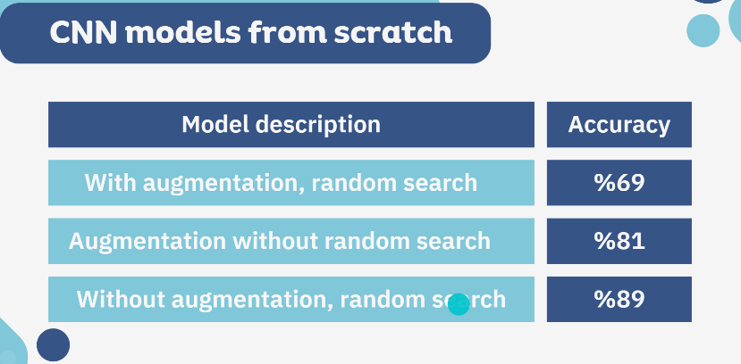

**Insights**: The dataset are already augmented and ready for model training, so when augmented, the accuracy will be lower

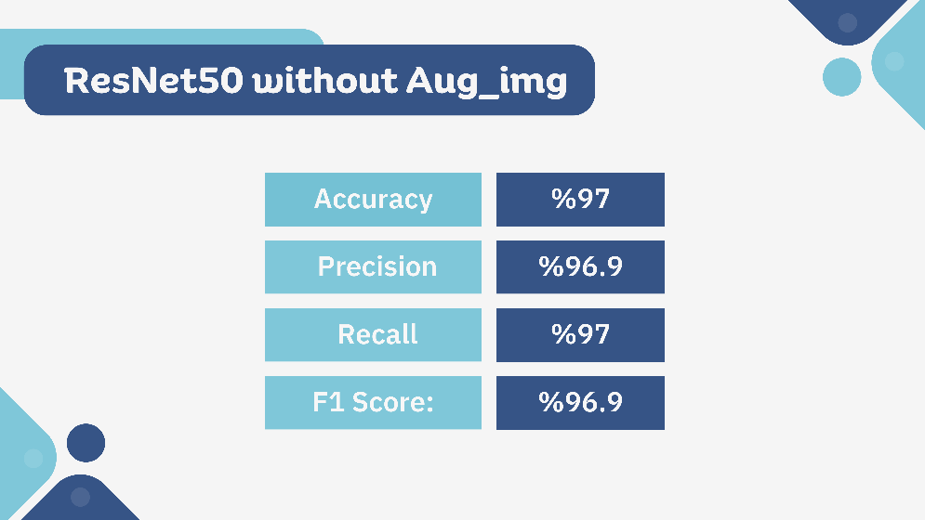**Pre-Trained Model:**

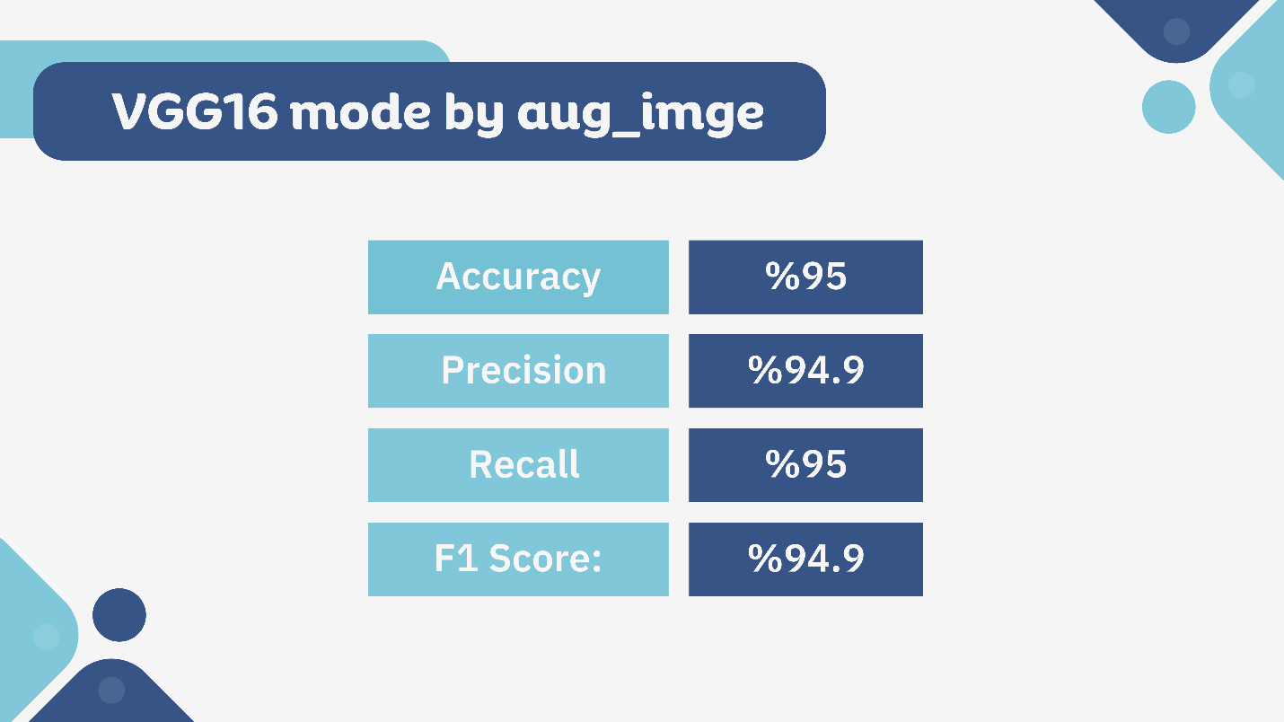

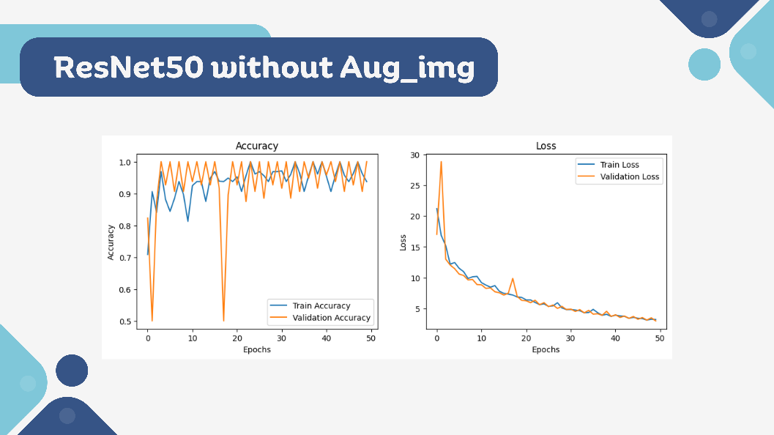

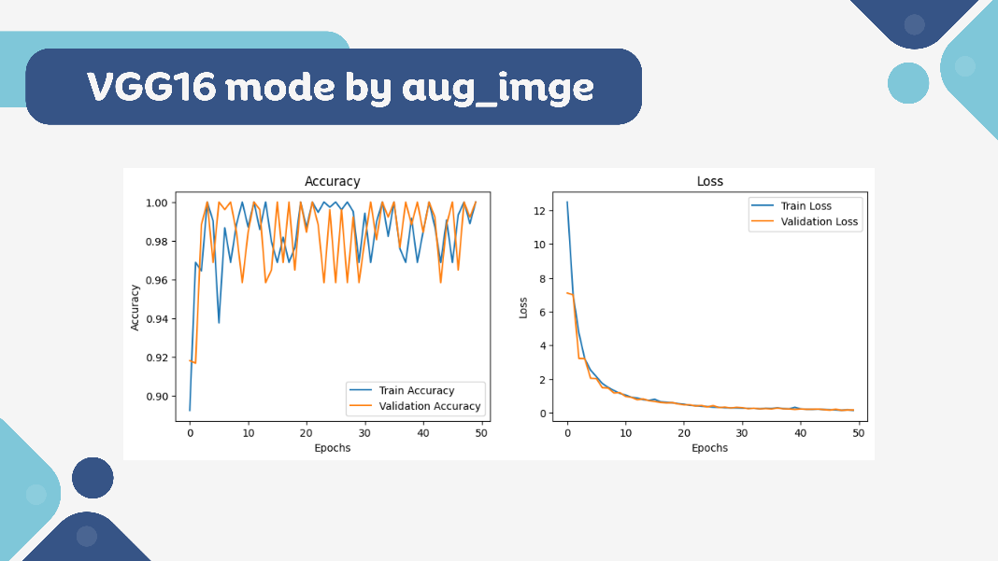

Insights:

* it shows us that pre-trained CNN models are more accurate than CNN models made from scratch.
* ResNet50 model has the highest accuracy which is 97%

**Challenges:**

* Increase accuracy(underfitting).
* Connection with MongoDB.
* When connecting the collab to MongoDB, many problems appear, the most prominent of which is URI and the account secret number must be added correctly.
* Computational power.
* When the size of the training data increases, some problems appear, such as an increase in the Run time and also the accuracy.
* Data collection.
* The required data was not found that easily. The data may be incomplete or not compatible with the project requirements.

**Future Work:**

1. Implement the idea in the most accident frequency regions.
2. Widen the dataset to be at night.
3. Use Pre-Trained models for more accurate results

**Team Member (**Ghadeer Nooh , Asma Alzibedi, Lama Alqahtan**)**

**Presentation (**https://www.canva.com/design/DAGN5iXtZN4/MO_QVxsykj90HCqEgJ7Psg/edit**)**